

StudyLabs
Final Project Definition

By:
Shimi Manashirov
Tamir Shoval
Niv Shapira 211838339
Ofek Saar 322605312
Idan Tepper 212929103

Supervisor:
Eliav Menache

Table of Contents
1. PROJECT DESCRIPTION 2
2. RELATED WORK 2
3. FUNCTIONAL DESCRIPTION / REQUIREMENTS 2
4. ARCHITECTURE 3
4.1. Each Module description 3
5. WORK PLAN 3
6. CLIENT SIDE 3
6.1. Usage Illustration 3
6.2. Mockup 3
7. SERVER SIDE 3
7.1. API 4

1. Project Description
StudyLabs is an intelligent digital learning platform designed to transform passive academic study into an engaging, gamified experience. By bridging the gap between traditional course management and modern user engagement, StudyLabs provides structured, syllabus-based learning paths. The system leverages AI to convert static course materials (PDFs, recordings, syllabi) into interactive summaries and practice modules, while offering educators data-driven insights into student performance.

2. Related Work
The project builds upon and improves features found in several existing platforms:
- Moodle: Used for course management and materials, but lacks gamification and gradual "progress paths".
- Quizlet: Offers flashcard practice but lacks structured learning paths or academic course alignment.
- Duolingo: Provides excellent gamification and stage-based learning, but is limited to language studies.
- Kahoot: Engaging for group trivia, but lacks individual tracking and long-term academic structures.
- NotebookLM: Effective for information retrieval from documents, but lacks gamification and instructor-facing dashboards.

3. Functional Requirements

3.1 Student Interface (The Learning Journey)
- Authentication: Secure Login/Signup via email and password.
- Course Dashboard: A personalized view of all courses the student is enrolled in.
- The Learning Map: A visual, stage-based "Map" (similar to a game world) representing the syllabus.
- Interactive Modules: Each lesson includes:
  - Study Cards: AI-generated summaries of the topic.
  - Multiple Choice Questions: Instant-feedback quizzes.
  - AI-Evaluated Open Questions: Students answer in free text, and the AI provides qualitative feedback.
- Engagement Tracking: Personal progress bars, "Daily Streaks," and a class leaderboard to encourage consistency.

3.2 Instructor Interface (The Management Hub)
- Course Creator: Define course descriptions and manage student rosters.
- Content Processor: A dedicated portal to upload syllabi, summaries, lecture recordings, and past exams.
- AI Orchestrator: Tools to review and approve AI-generated questions and paths before publishing.
- Analytics Dashboard: Real-time tracking of student XP, identifying bottlenecks where students are struggling, and monitoring class-wide "Streaks."

4. System Architecture & Modules

4.1 Module Breakdown
- Client-Side (React & Tailwind): A responsive SPA (Single Page Application) focusing on the "Map" visualization and the interactive quiz engine.
- Backend (Python): Handles routing, middleware for authentication (JWT), and request validation.
- AI Engine (LamaIndex): A specialized module that sends course content to LLMs with specific prompting to return structured JSON (quizzes/summaries).
- Gamification Logic: A backend service that calculates XP rewards, manages "Streaks," and unlocks new stages based on mastery scores.
- Data Layer (MongoDB): Stores user profiles, course structures, and progress snapshots.

5. Work Plan & Responsibilities
- Frontend (UI/UX): Developing the "Learning Map" UI and Instructor Dashboard.
- Backend (API & Logic): Building the Express server and gamification scoring algorithms.
- AI Implementation: Engineering prompts for syllabus-to-quiz conversion and open-answer evaluation.
- Database & QA: Managing MongoDB schemas and ensuring data integrity between student attempts and instructor views.

6. Mockup
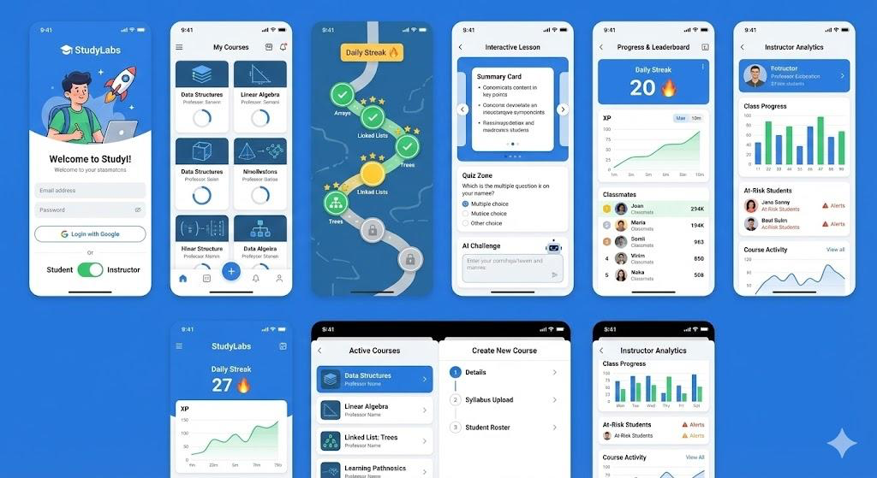

7. Server Side
The server side handles the business logic, integrating the AI engine with the database to ensure data consistency and personalized learning experiences.

7.1. API
To execute this, the backend will be organized into the following RESTful endpoints:

7.1.1 Auth & Users
- POST /api/auth/register & login: User onboarding.
- GET /api/users/me/progress: Fetches current streaks and total XP.

7.1.2 Course & Content (Instructor)
- POST /api/courses/create: Initialize a new course shell.
- POST /api/courses/:id/upload: Endpoint for PDF/Syllabus processing.
- POST /api/courses/:id/generate: Triggers the AI to create the "Learning Map" from uploaded files.
- GET /api/courses/:id/analytics: Returns student progress data for the instructor dashboard.

7.1.3 Learning Path (Student)
- GET /api/courses/my-courses: List of courses the student is invited to.
- GET /api/courses/:id/map: Returns the stages, lessons, and "locked/unlocked" status.
- POST /api/lessons/:id/submit: Validates quiz answers and updates student XP.
- POST /api/lessons/:id/evaluate-open: Sends an open-ended answer to the AI for grading and returns feedback.

8. Technical References & Implementation Suggestions

8.1 Core Technologies
- Language: Python 3.10+
- Framework: FastAPI (Recommended for high-performance AI applications) or Flask.
- RAG Framework: LlamaIndex – Used to index course PDFs and recordings to provide context-aware summaries and quiz generation.³
- LLM: OpenAI GPT-4o / GPT-4o-mini.
- Database: MongoDB (for flexible document storage) and Supabase (for Auth).

8.2 LlamaIndex Implementation Suggestion
To make StudyLabs truly "intelligent," we suggest implementing LlamaIndex in the following way:
- Data Ingestion: When an instructor uploads a PDF syllabus or summary, LlamaIndex will parse the document into "Nodes."⁴
- Vector Store: These nodes are stored in a vector index (using VectorStoreIndex).⁵
- Contextual Question Generation: Instead of sending a huge text to OpenAI, you use a QueryEngine to find the most relevant parts of the material to generate a specific quiz for a lesson.
- AI Grader: For open-ended questions, LlamaIndex can retrieve the exact paragraph from the study material to check if the student's answer matches the instructor's content.

8.3 Recommended Python Libraries
Library | Purpose
llama-index | To manage document indexing and retrieval logic.
motor | An asynchronous Python driver for MongoDB.
pydantic | For data validation and settings management.
fastapi | Python framework for running the backend application
openai | The official client for LLM interaction.
PyPDF2 / LlamaParse | For high-accuracy parsing of complex academic PDFs.

8.4 Academic & Technical References
- LlamaIndex Documentation: "High-level API for connecting external data to LLMs."
- Gamification in Education: Deterding, S., et al. (2011). "From Game Design Elements to Gamefulness: Defining Gamification."
- RAG Best Practices: Lewis, P., et al. (2020).⁶ "Retrieval-Augmented Generation for Knowledge-Intensive NLP Tasks."

משימות לקראת פגישה 2:

סיכום מנהלים:
- צריך להגדיר את האוטפוט של הllm כמו שצריך בפורמט מוגדר תואם לשאלות
  - מקבל אינפוט שכולל הרבה דברים וצריך להוציא משהו מוגדר ו Structured
- נדרש להציג איך נצליח לקבל מה llm אתה מה שאנחנו צריכים בשביל לייצר את הקורס
- נדרש לנסות ידנית לקחת קורס לדוגמה ולראות שאפשר לייצר ידנית את השאלות והתוכן ממנו
- הצגה יותר מעמיקה של מסך הלמידה - איך נראה תהליך הלמידה עם עקרונות גיימיפיקציה
  - לראות איך המסך מוגדר שמכאן נגזור את התוצר של מערכת הניתוח של הקורס
לתת דגש על:
איך מערכת ניתוח הקורס עובדת:
- מה האינפוט ומה האווטפוט
- לא פרומפט אחד - תהליך יעיל

להצגה הבאה להציג גם מיילסטונים ותכנית עבודה

מה תכלס צריך לעשות:

- להכין poc של ה ai שמגנרט קורס - באחריות תמיר ושימי
- להכין את מסך הלמידה בצורה מפורטת - באחריות ניב
- להכין מצגת גאנט ותכנית עבודה - באחריות טפר

איזה פורמט ה AI צריך להחזיר:

סילבוס -> JSON : חלוקה לשיעורים ונושאים בכל שיעור (Pydentic)
חומרי למידה (טקסט) ~שלב OCR~ -> תיוגים חומר לנושא
יצירת שאלות על בסיס חומר לכל נושא

{
First class:{topic1:description ,topic2:description ,....,topicn:description },
.
.
.
.
.
N class:{topic1:description ,topic2:description ,....,topicn:description },
}

